Table of Contents

Table of Figures 1
1. Design Explanation – Smart Water Gate System 2
Key Parts & Their Functions: 2
Gate in Closed Position: 4
Gate in Open Position: 4
2. Design Explanation - Pot-Based Paddy Irrigation Prototype 5
Components & Their Functions 5
3. Integrated System Design: Water Gate to Pot-Based Irrigation 6
Description of the Integrated System: 6
Predictive Model for Water Requirement: 7
System Behavior: 7
Key Integration Points: 7

Table of Figures

Figure 1: Water tank with water gate 2
Figure 2: Gate in closed position 4
Figure 3: Gate in open position 4
Figure 4: Pot based paddy irrigation 5
Figure 5: Water gate to pot based irrigation 6

1. Design Explanation – Smart Water Gate System
Overview:
The system is a vertically sliding water gate used to regulate water flow in paddy fields. It uses a NEMA 17 stepper motor connected to a lead screw, which lifts or lowers the gate panel. The design ensures precision, automation, and protection against over-irrigation or water shortage.

Key Parts & Their Functions:

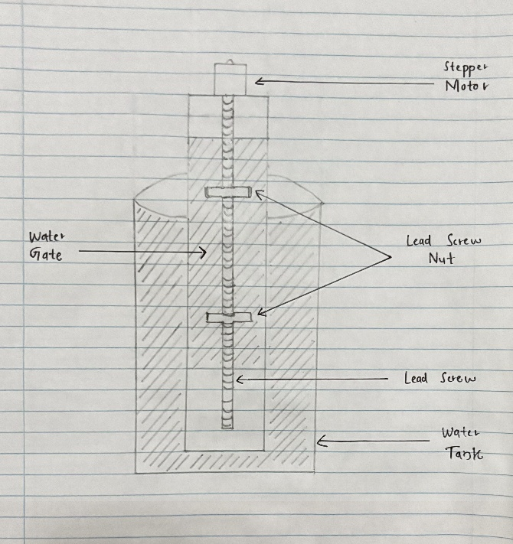
Figure 1: Water tank with water gate

• Water Tank / Canal
- Purpose: Holds or channels the irrigation water.
- Description: This is the section from which water is either held back or released depending on the gate position.
- Placement: Below and behind the gate door.
• Gate Panel (Sliding Door)
- Purpose: Acts as a barrier that controls water flow.
- Material Suggestion: Stainless steel, acrylic, or treated wood (to resist corrosion and pressure).
- Movement: Moves vertically up to open and down to close.

• Lead Screw
- Purpose: Converts the motor’s rotational motion into linear motion to raise/lower the gate.
- Type: TR8x8 or T8 threaded rod.
- Mounted Between: Stepper motor (top) and gate nut (fixed to panel).
• Lead Screw Nut
- Purpose: Attached to the gate; travels along the screw when it rotates.
- Note: This nut moves up/down while preventing rotation. It’s critical that it’s fixed to the gate and constrained against rotation.
• NEMA 17 Stepper Motor
- Purpose: Provides precise rotational motion to the lead screw.
- Control: Driven by Raspberry Pi (through a driver like TMC2209 or A4988).
- Placement: Top of the gate frame.
Water Level Sensor
- Purpose: Measures the current water level in the tank or canal.
- Use: Helps determine whether the gate should be opened or closed based on tank water availability.
- Type Suggestions: Ultrasonic sensor (e.g., HC-SR04), float switch, or capacitive level sensor.
- Placement: Mounted inside or above the tank/canal facing the water surface.

Gate in Closed Position:
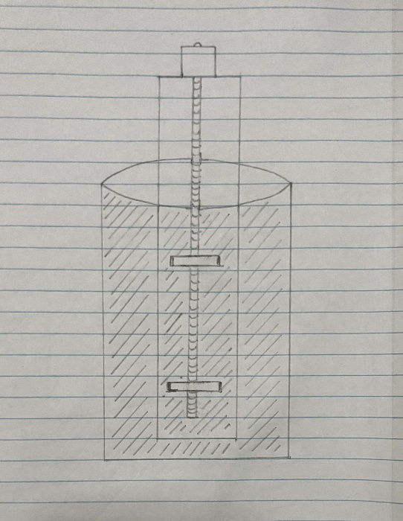

Figure 2: Gate in closed position

In the closed state, the gate is fully lowered into the water channel, blocking the flow of water completely.

Gate in Open Position:
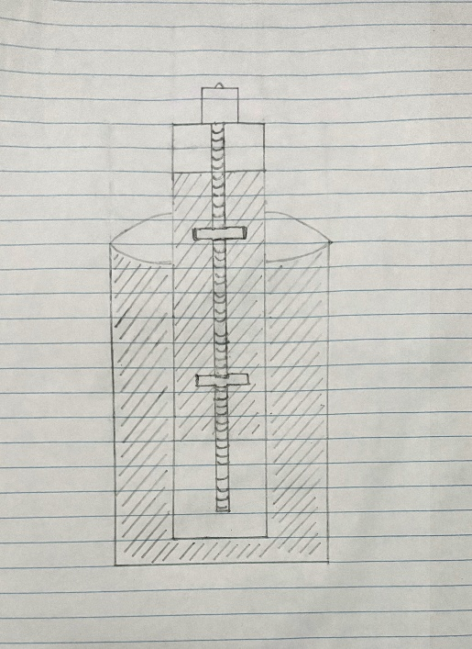

Figure 3: Gate in open position
In the open state, the gate is lifted vertically by the motor, allowing uninterrupted water flow through the channel.

2. Design Explanation - Pot-Based Paddy Irrigation Prototype
Objective:
This setup is used to simulate a real-world paddy field scenario in a controlled environment using a plastic pot. It helps test the functionality and responsiveness of the smart water gate system by monitoring moisture levels and rain detection.

Components & Their Functions
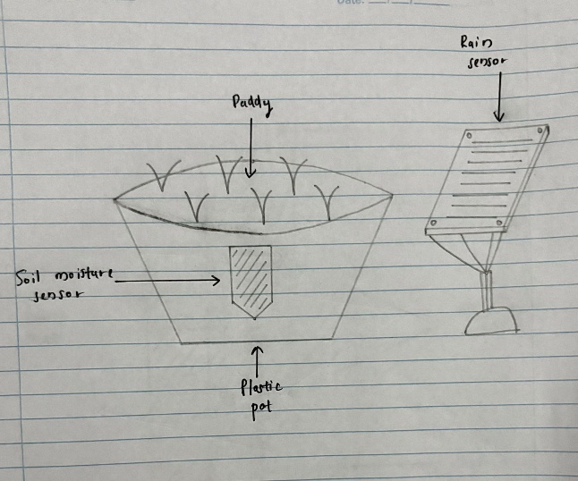

Figure 4: Pot based paddy irrigation

- Plastic Pot
- Purpose: Serves as a miniature paddy field for testing.
- Contents: Filled with soil and paddy plants.
- Advantage: Portable, safe for sensor trials, and easy to monitor in indoor/outdoor conditions.
- Paddy Plants
  - Purpose: Represent the crop being cultivated.
  - Significance: Soil moisture and water level are monitored to ensure the ideal growing environment.
- Soil Moisture Sensor
  - Placement: Inserted into the soil inside the plastic pot.
  - Purpose: Measures real-time soil moisture content.
  - Output: Analog or digital values sent to the controller (Raspberry Pi or Arduino).
  - Use Case: Triggers irrigation when moisture falls below a defined threshold.
- Rain Sensor (YL-83)
  - Placement: Positioned next to the pot in an elevated and exposed angle.
  - Purpose: Detects the presence of rain.
  - Output: Sends a digital LOW signal when raindrops are detected.
  - Use Case: Prevents irrigation during rainfall to conserve water.

3. Integrated System Design: Water Gate to Pot-Based Irrigation
The following diagram represents the complete integrated setup combining the smart water gate system and the pot-based paddy irrigation unit. This configuration demonstrates a closed-loop intelligent irrigation system where decisions are made based on real-time sensor data and predictive modeling.
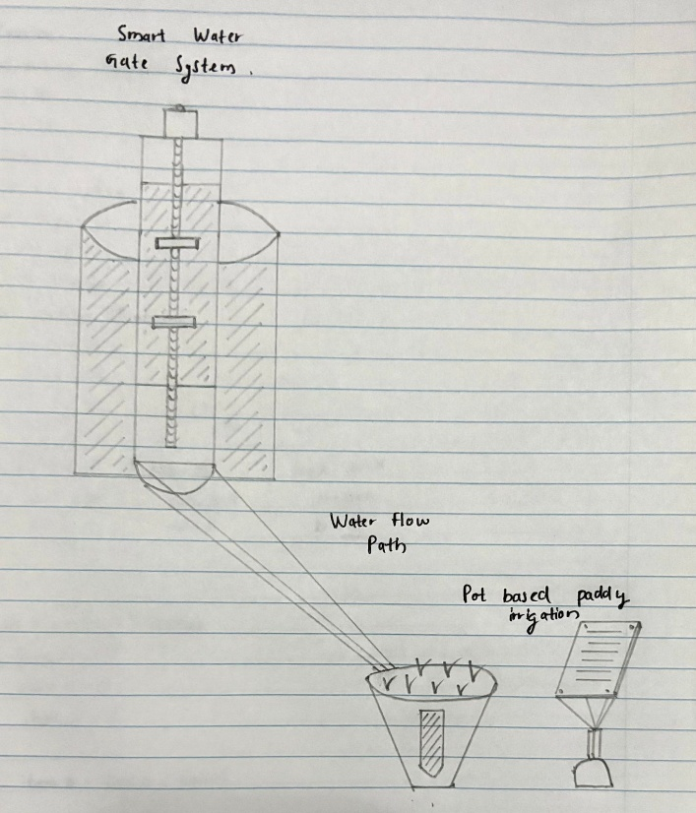
Figure 5: Water gate to pot based irrigation

Description of the Integrated System:
- On the left side, the Smart Water Gate System is installed over a cylindrical water tank. It consists of a NEMA 17 stepper motor and a lead screw mechanism that lifts or lowers the gate vertically to regulate water flow.
- Inside the tank, a Water Level Sensor is positioned to monitor the available water. This data is crucial for predicting whether irrigation can proceed.
- When the gate is opened, water exits the tank via the Water Flow Path—a sloped channel or pipe that delivers water to the crop area.
- On the right side, the Pot-Based Paddy Irrigation Unit is positioned to receive this water. It includes:
  - A Soil Moisture Sensor embedded in the soil to detect real-time moisture levels.
  - A Rain Sensor placed nearby to detect rainfall events.
  - A plastic pot filled with soil and planted with paddy to simulate field conditions.

Predictive Model for Water Requirement:
To enhance automation, a machine learning model is used to predict the current water requirement for the paddy crop. The model takes the following inputs:
- Soil Moisture Level
- Water Level in the Tank
- Other (temperature, future rainfall etc.)
Based on these inputs, the model outputs whether irrigation is currently needed. This decision is then used to control the gate mechanism.

System Behavior:
Condition | System Response
Model predicts water is needed and no rain detected | Gate opens, water flows to the pot
Soil is moist or rain is detected | Gate remains closed
The tank water level is too low | Gate remains closed, irrigation blocked
- The gate closes automatically once the moisture level is sufficient or if rainfall is detected.
- The system ensures minimal water usage by combining sensor readings with model-based prediction.

Key Integration Points:
Component | Connected To / Function
Smart Water Gate | Controls the physical release of water from the tank
Water Level Sensor | Sends real-time tank level data to the prediction model
Soil Moisture Sensor | Monitors current soil dryness and sends data to the model
Rain Sensor | Prevents water gate operation during natural rainfall
Water Flow Path | Transfers water from the tank directly to the paddy pot
Predictive Model | Computes whether irrigation is required (based on sensor input)
Paddy Pot | Final recipient of the irrigated water

